**SIMULATION OF EMPLOYMENT BENEFITS PLAN BY SAFELANE INSURANCE**

horizontal line

# 

# 

Mahima Doshi

Kartik Sharma

Nistha Rulania

Jaishvin Kaur

# Index

1. INTRODUCTION
2. OBJECTIVE
3. METHODOLOGY
4. LIMITATION
5. SAFELANE PORTFOLIO MANAGEMENT SCHEME
6. CONCLUSION

# 

# Introduction

Safelane Insurance Company began its operations in the fiscal year 2005 and has been amongst the top companies in the insurance sector.

Safelane offers long term savings and protection products to meet different life stage requirements of our customers. We have developed various cost-effective products with premium quality services and a hassle-free claim settlement experience for our customers.

The Company has a well-diversified portfolio of insurance products and solutions, tailored to the specific needs of the customers. We offer a range of products across the customer’s life cycle, including children's future plans, wealth protection plans, retirement and pension solutions, health plans among many more.

Apart from this, our company also believes in providing the best facilities and benefits to our employees.

Employee benefits play an increasingly important role in the lives of employees and their families and have a significant financial and administrative impact on a business organization. Most companies operate in an environment in which an educated workforce has come to expect a comprehensive benefits program. Indeed, the absence of a program or an inadequate program can seriously hinder a company’s ability to attract and retain good personnel.

Consequently, organizations increasingly offer a wide range of traditional and nontraditional benefits; a 2011 Society for Human Resource (SHRM) survey identified 284 such offerings.

A major challenge for businesses is combining the right mix of benefits to attract and retain top performers while also balancing the increasing costs of those benefits. The same SHRM survey reported that businesses spent an average of 19% of an employee’s annual salary on mandatory benefits (such as unemployment, workers’ compensation, and Social Security), 19% on voluntary benefits (such as medical plans, dental plans, prescription coverage, flexible spending accounts, vision plans, and survivor benefits) and 11% on pay for time not worked benefits (regular rate of pay for a non-working period of time, such as vacations, holidays, personal, and sick leave).

**Benefits provided by Safelane Insurance:**

There are some mandatory benefits provided by our company which include

1. Leave of Absence is an employee’s right

2. Workplace security

3. Payment of Gratuity

4. Required retirement benefits and incentives

5. Worker’s compensation

6. Maternity Benefit

7. Health insurance

8. Life insurance

Apart from this, there are some additional benefits provided by our company like **free membership at Safelane Club**, **free skill-development workshops**, **basic transportation Cost**. But the main benefit provided by us is the **Investment Plan** made by our company for the benefit of our employees.

**What does this plan include?**

In this plan, we take a certain percentage of the employee’s salary and invest it in Safelane Portfolio Management Services at a certain interest rate upon which you receive the sum assured on the maturity of tenure. The plan provides life coverage and also acts as an investment. This investment can help the employees meet up all their future goals.

**Benefits:**

1. This plan is reliable and provides our employees with security and flexibility.
2. The employees get regular cash flows at intervals and can easily meet up with all their financial obligations

**Objective:**

1. The main objective of our company is to attract and retain extraordinary employees and improve their efficiency.
2. To fulfill the needs of employees which they themselves cannot attain.
3. To provide some special allowance to the employees to enhance their standard of living to increase their quality of working life.

# Methodology:

Working with the tools of actuarial science, the process of calculating sum assured for the employees is :

1. The amount of money that we will be investing is allocated according to the salary i.e.

|  |  |
| --- | --- |
| **Salary(per month)** | Percentage |
| Greater than 4 lakh | 15% |
| 4 Lakh - 2.9 Lakh | 12% |
| 2.9 Lakh - 1.5 Lakh | 10% |
| 1.5 Lakh - 65 Thousand | 8% |
| Less than 65 Thousand | 7% |

1. The interest rate has been calculated using the following formula:

**Interest Rate=1.75 (Investment Code)+0.75 (Tenure)**

1. Calculation of sum assured:

Let us take an example to calculate the sum assured after 2 years.

**S1 = P(1+i)**

**S2 = (S1+P)(1+i)**

**.**

**.**

**.**

**S24 = (S23 +P)(1+i)**

Here, S1 is the sum assured after 1st month, S2 after 2nd month, and similarly, S24 is the final sum assured that would be provided to the employees after 2 years where ‘i’ is the interest rate per month.

|  |  |  |  |  |  |  |  |  |  |
| --- | --- | --- | --- | --- | --- | --- | --- | --- | --- |
| Post (non contractual regular employees) | Age ( in years) | Salary ( in Rs./month) | Investment Of Salary | Interest 4 years | Interest 3 years | Interest 2 years | sum assured (4) | sum assured (3) | sum assured (2) |
| Insurance Director | 55 | 472000 | 70800 | 10 | 9.25 | 8.5 | 4489911.487 | 3087766.262 | 1902635.827 |

*The calculation of sum assured for Insurance Director

The calculated sum assured for each employee according to their tenure and the total profit earned by our company is given in the **excel link** below:

<https://docs.google.com/spreadsheets/d/1K-RmVFqq30jnGAtXK6ra-wzIjHhq_3qrfsbmNvtCiZk/edit?ts=5f466e21#gid=876987294>

Also the **python code** for the same is:

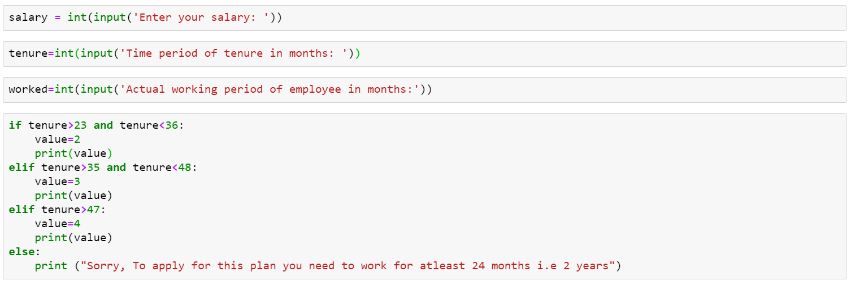

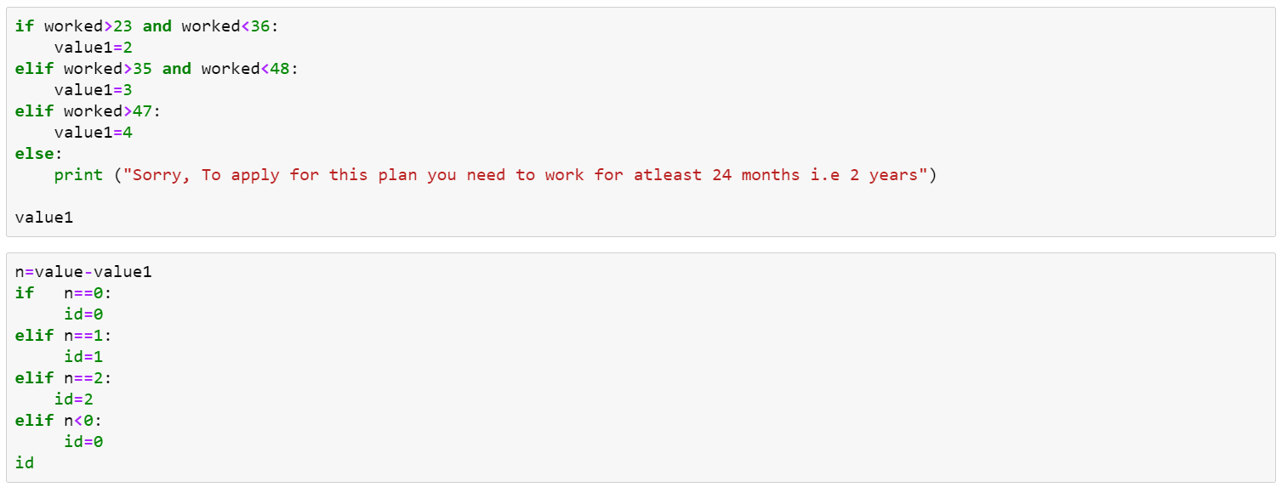

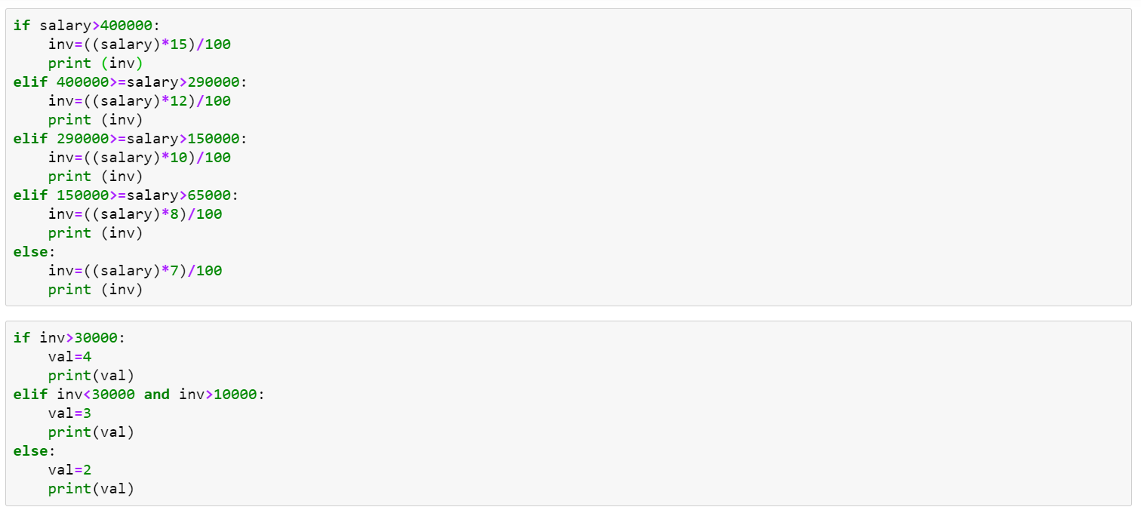

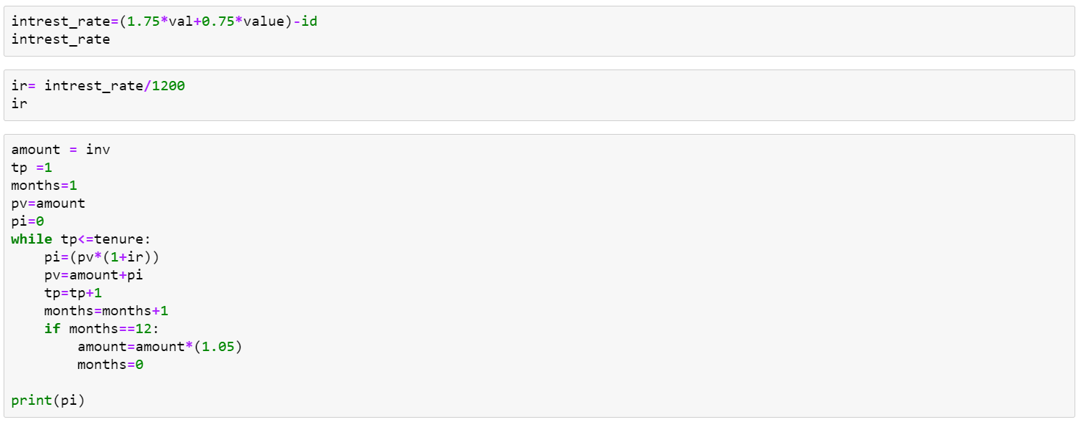

**Safelane Portfolio Management Services:**

1. **Portfolio :**

A portfolio refers to a collection of investment tools such as stocks, shares, cash and so on depending on the investor’s income, budget and convenient time frame.

1. **Portfolio Management :**

The art of selecting the right investment policy for the individuals in terms of minimum risk and maximum return is called portfolio management.

Portfolio management refers to managing an individual’s investments in the form of bonds, etc so that he earns the maximum profits within the stipulated time frame.

In a layman’s language, the art of managing an individual’s investment is called portfolio management.

**Need for Portfolio Management :**

1. Portfolio management presents the **best investment plan** to the individuals as per their income, budget, age and ability to undertake risks.
2. It **minimizes the risks** involved in investing and also increases the chance of making profits.
3. Portfolio managers understand the client’s financial needs and suggest the best and unique investment policy for them with minimum risks involved.
4. It enables the portfolio managers to **provide customized investment solutions** to clients as per their needs and requirements.

At Safelane Insurance Company, our main focus is not only to cater personal financial assistance but also to empower wealth creation over a long haul of time through total return policy led by compound annual growth rate.

The goal will be to design a portfolio that balances the requirements of liberal income with sufficient liquidity to withstand down market.

## Key Elements of Portfolio Management

### Asset Allocation

The key to effective portfolio management is the long-term mix of assets. Generally, that means stocks, bonds, and "cash" such as certificates of deposit. There are others often referred to as alternative investments, such as real estate, commodities, and derivatives.

Asset allocation is based on the understanding that different types of assets do not move in concert, and some are more volatile than others. A mix of assets provides balance and protects against risk.

### Diversification

The only certainty in investing is that it is impossible to consistently predict winners and losers. The prudent approach is to create a basket of investments that provide broad exposure within an asset class.

Diversification is spreading risk and reward within an asset class. Because it is difficult to know which subset of an asset class or sector is likely to outperform another, diversification seeks to capture the returns of all of the sectors over time while reducing volatility at any given time.

Real diversification is made across various classes of securities, sectors of the economy, and geographical regions.

### Rebalancing

Rebalancing is used to return a portfolio to its original target allocation at regular intervals, usually annually. This is done to reinstate the original asset mix when the movements of the markets force it out of balance.

For example, a portfolio that starts out with a 70% equity and 30% fixed-income allocation could, after an extended market rally, shift to an 80/20 allocation. The investor has made a good profit, but the portfolio now has more risk than the investor can tolerate.

This generally involves selling high-priced securities and putting that money to work in lower-priced and out-of-favor securities.

The annual exercise of rebalancing allows the investor to capture gains and expand the opportunity for growth in high potential sectors while keeping the portfolio aligned with the original risk/return profile.

**All asset classes past total return history:**

1. **Global Equity:**

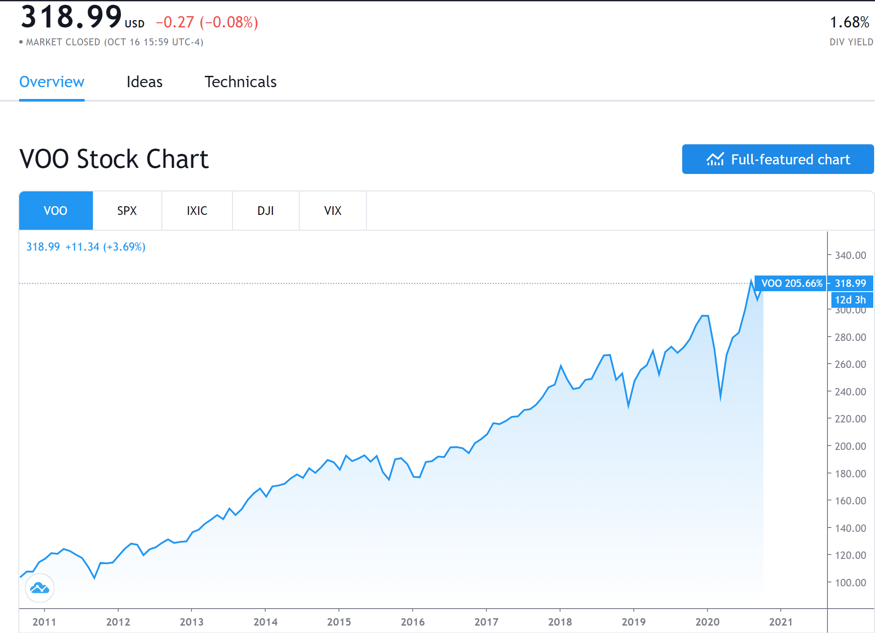

1. **Sensex:**

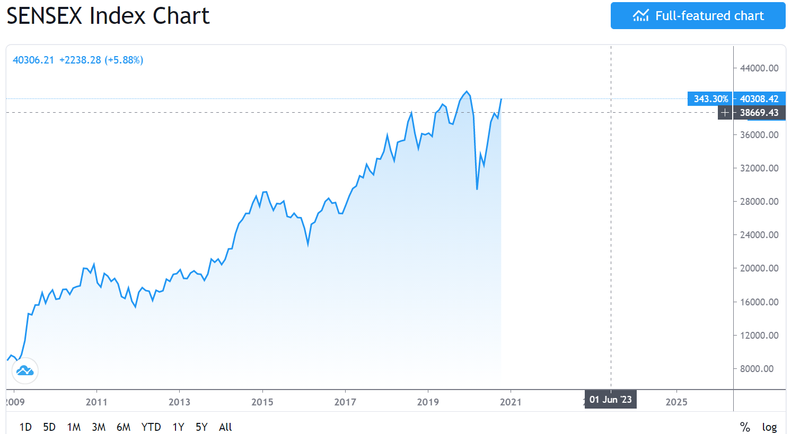

1. **Nifty**

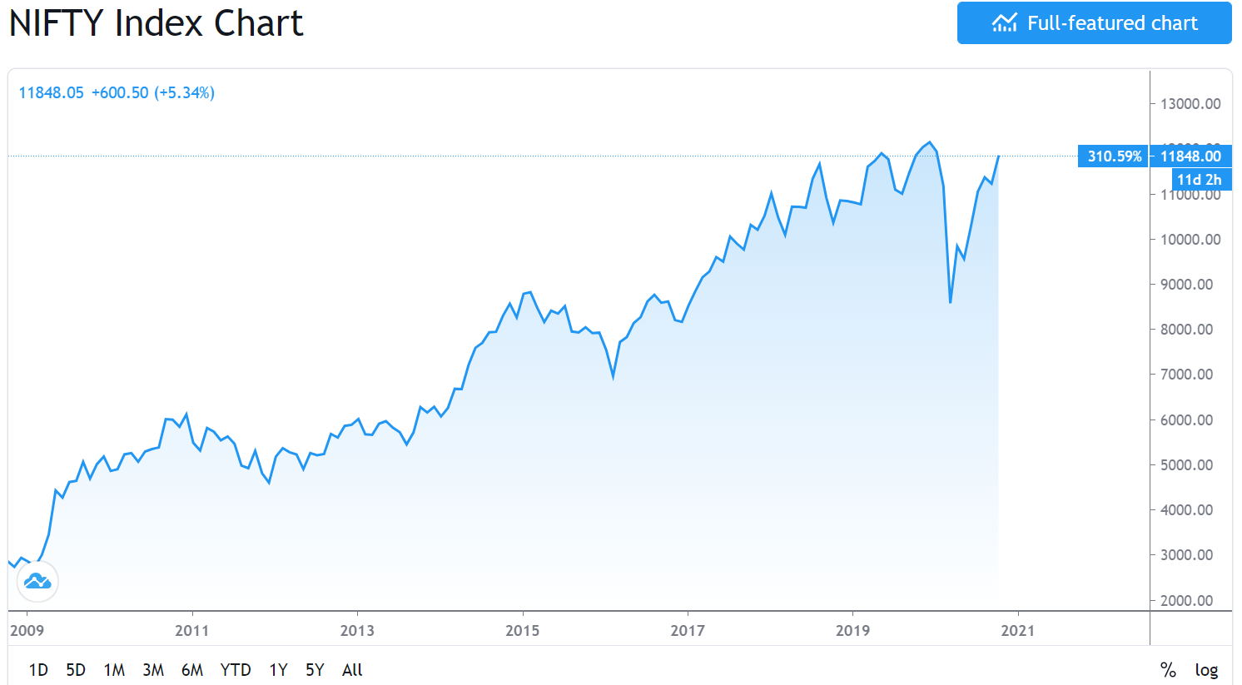

1. **Debt Funds & Bonds:**

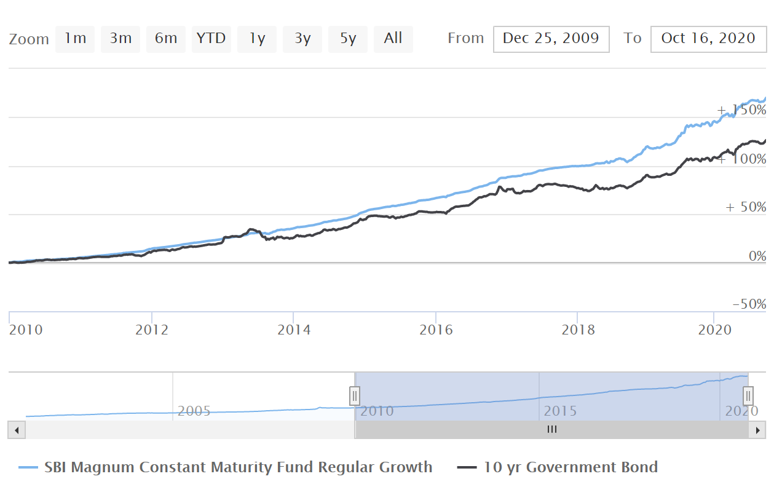

1. **Government Security & PPF:**

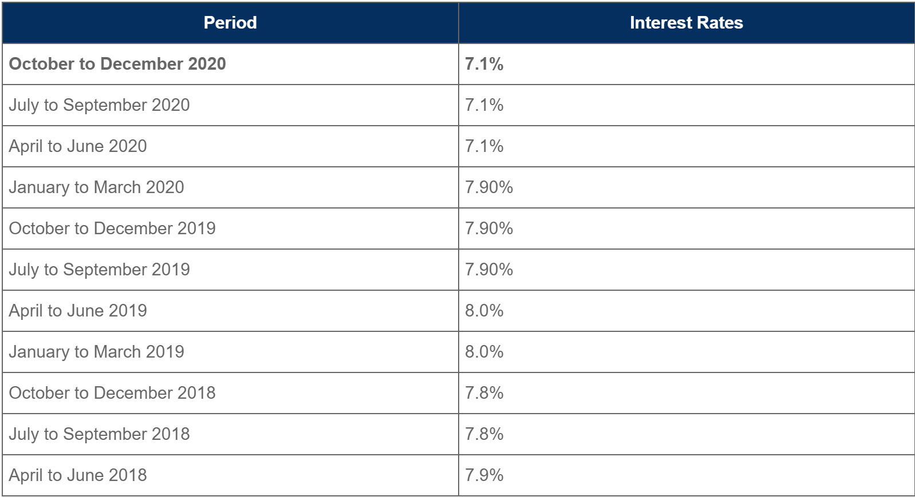

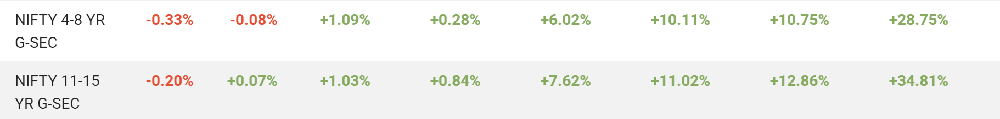

1. **Commodities (Gold etc.):**

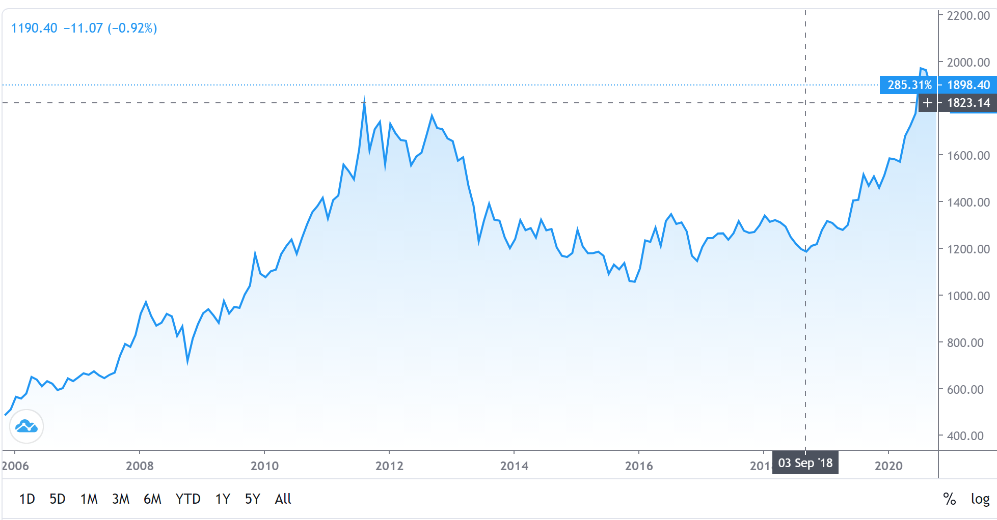

**Acronyms:**

1. **Global Equity:** Global equity and markets refers to global index, investing a corpus in global index is equivalent to participating in foreign or global economy. It not only only ensures the rewards from the economic boom from a global perspective but it also helps in appreciation of wealth.
2. **Indian Indices and Equity :** Indian indices comprises sensex which largely contains the top 30 businesses of india and nifty which covers the top 50 companies of india. Investing in the indian equity doesn’t only give huge rewards it also showers with the various perks like bonuses, splits, and dividends which can catapult the wealth of any portfolio. Largely the past ten year returns of indices are pretty decent giving the average return of 12%-15% YOY on compound basis.
3. **Govt. Sec. & Bonds :** A bond is a fixed income instrument that represents a loan made by an investor to a borrower (typically corporate or governmental). A bond could be thought of as an I.O.U between the lender and borrower that includes the details of the loan and its payments. Bonds are used by companies, municipalities, states, and sovereign governments to finance projects and operations. Owners of bonds are debtholders, or creditors, of the issuer. Bond details include the end date when the principal of the loan is due to be paid to the bond owner and usually includes the terms for variable or fixedinterest payments made by the borrower.

A Government Security (G-Sec) is a tradable instrument issued by the Central Government or the State Governments. It acknowledges the Government’s debt obligation. Such securities are short term (usually called treasury bills, with original maturities of less than one year) or long term (usually called Government bonds or dated securities with original maturity of one year or more). In India, the Central Government issues both treasury bills and bonds or dated securities while the State Governments issue only bonds or dated securities, which are called the State Development Loans (SDLs). G-Secs carry practically no risk of default and, hence, are called risk-free gilt-edged instruments. Cumulatively the govt. Securities and bonds have given the average return of 8%-11% YOY basis.

1. **PPF & Commodities:** PPF is a pension fund which is collaboratively governed by post office and RBI. It focuses on the risk free return for investors foreseeing retirement. It annually gives the return of 7%-8% compounded. Commodities such as gold and silver rebalances the portfolio and can act as a hedging tool for portfolio. It is beneficiary in the case of the wild swings the market takes which are not in favour of investors. Gold and silver has given a return of 285% and 256% over the duration of 10 years respectively.

**Portfolio Asset Allocation**

1. **Conservative Portfolio**

Conservative portfolio focuses on the class of investors or employees which belongs to risk aversion, someone who doesn't appreciate unnecessary risk. It does focus on fixed income but comes with a slow growth rate.

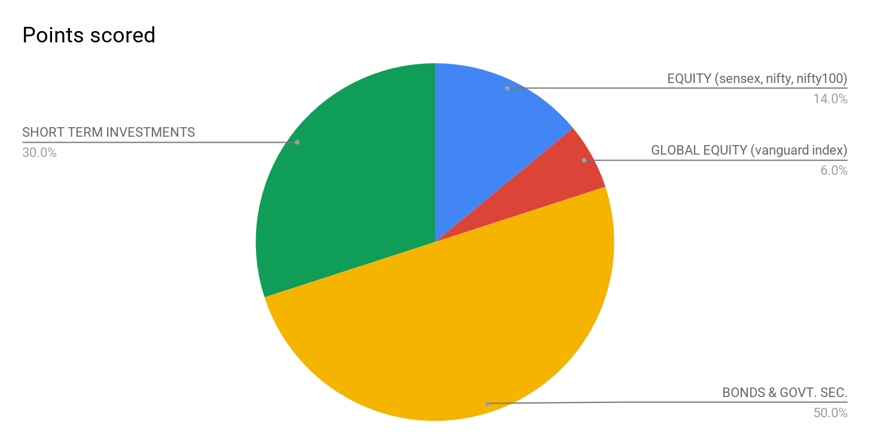

1. **Balanced Portfolio:**

Balanced portfolios are for investors or employees who love the proper amalgamation of risk and reward. The balanced portfolio gives out the best returns risk adjusted. It is one of the decent portfolio allocation for moderate risk investors.

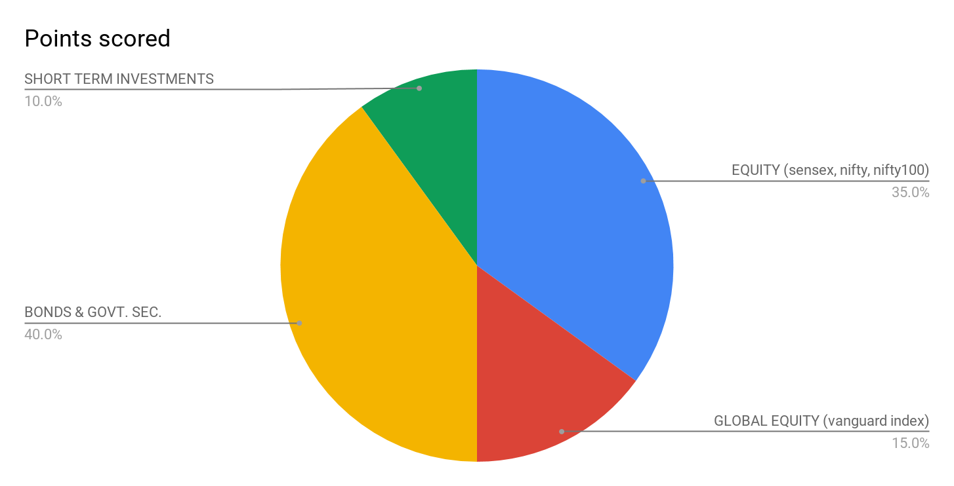

1. **Growth Portfolio :**

Growth portfolio comprises much appreciated risk but with much greater returns. It mainly focuses on the growth aspects of the overall allocation and hence caters the most handsome returns over the long period of time with much greater pace.

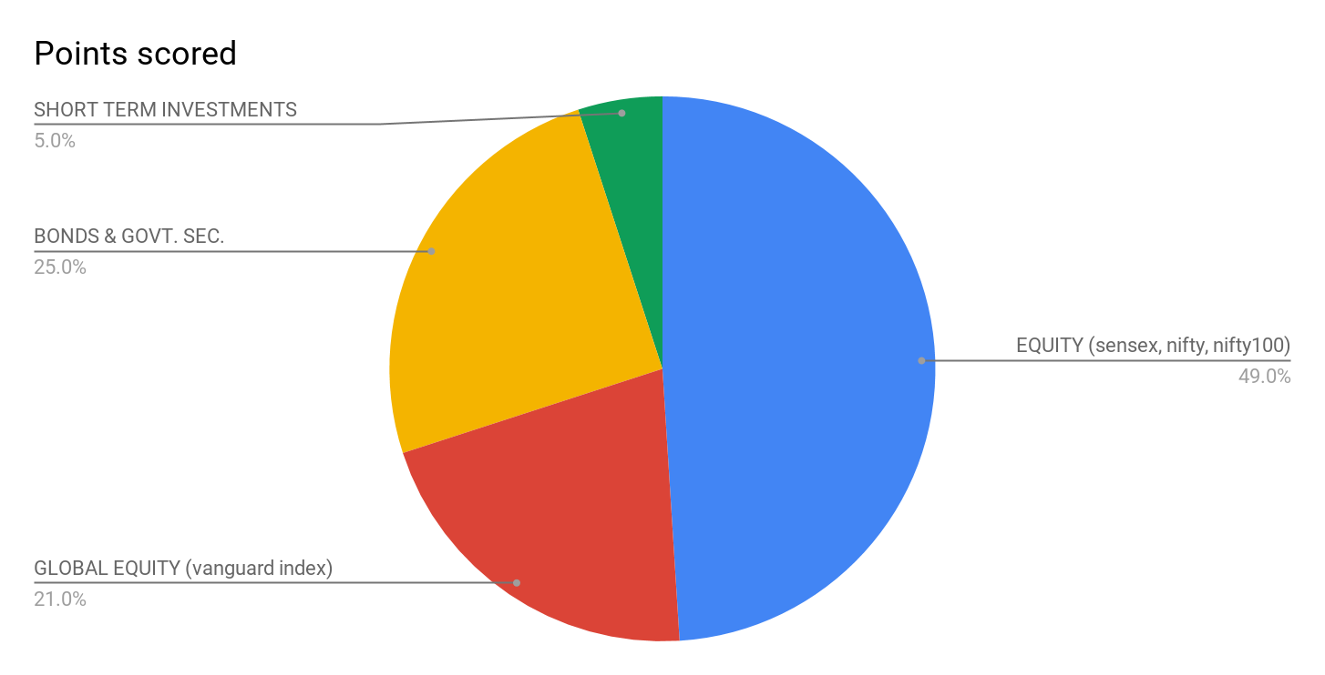

**Terms & Conditions:**

The investment plan has certain terms and conditions which must be complied by all the employees who sign up for this benefit. They are :

1. Any employee who has signed up for this plan has to compulsorily work for 2 years in the company.
2. Any employee in this plan who leaves before his/her tenure has been completed will not receive the same sum assured instead the interest rate will be lowered by 2%.

**Conclusion:**

We are proud to provide a comprehensive flexible and highly competitive benefits program as an important component of our total rewards package.

Employee benefits is one tool to make our team feel valued, appreciated, and loyal. Ranging from health benefits, to retirement savings, to flexible schedules employees want to work for a company that makes them feel secure and satisfied.

In conclusion, providing such an investment plan will be beneficial for employees and the company.

The plan will also increase our goodwill in the market.